**DAILY ONLINE ACTIVITIES SUMMARY**

|  |  |  |  |  |  |  |  |  |
| --- | --- | --- | --- | --- | --- | --- | --- | --- |
| **Date:** | **31-5-2020** | | | | | **Name:** | **Prajna** | |
| **Sem & Sec** | **8th sem ‘B’** | | | | | **USN:** | **4AL16CS067** | |
| **Online Test Summary** | | | | | | | | |
| **Subject** | | **IOT** | | | | | | |
| **Max. Marks** | | **20** | | **Score** | | | **17** | |
| **Certification Course Summary** | | | | | | | | |
| **Course** | **Frond end development html** | | | | | | | |
| **Certificate Provider** | | | **Great Learning** | | **Duration** | | | **30min** |
| **Coding Challenges** | | | | | | | | |
| **Problem Statement:**1**.** Write a c program to find the product of an array elements.  **2.**write a c program to print the factorial of the given number | | | | | | | | |
| **Status: Completed** | | | | | | | | |
| **Uploaded the report in GitHub**  **GitHub link:** | | | | | **Yes**  **https://github.com/alvas-education-foundation/prajna_k** | | | |
| **If yes Repository name** | | | | | **prajna_k** | | | |
| **Uploaded the report in slack** | | | | | **yes** | | | |

Online Test Details: (Attach the snapshot and briefly write the report for the same)

Certification Course Details: (Attach the snapshot and briefly write the report for the same)

Coding Challenges Details: (Attach the snapshot and briefly write the report for the same)

1)online test

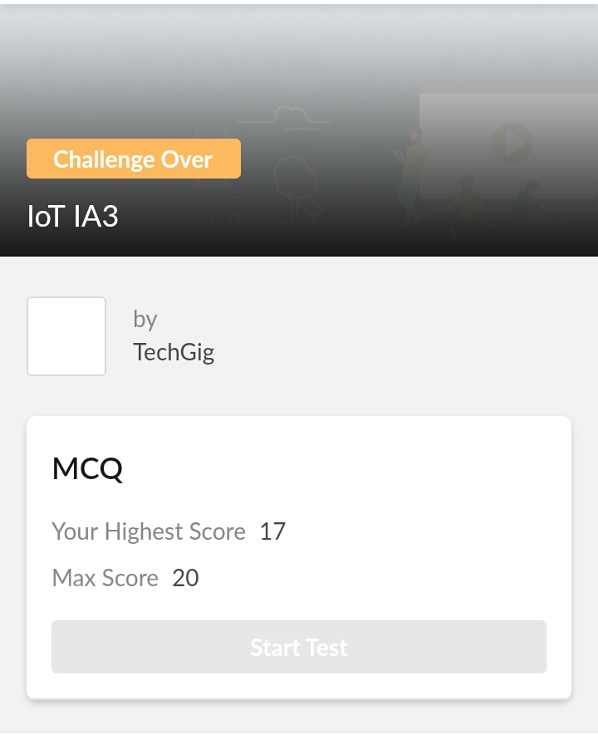

2) certification course

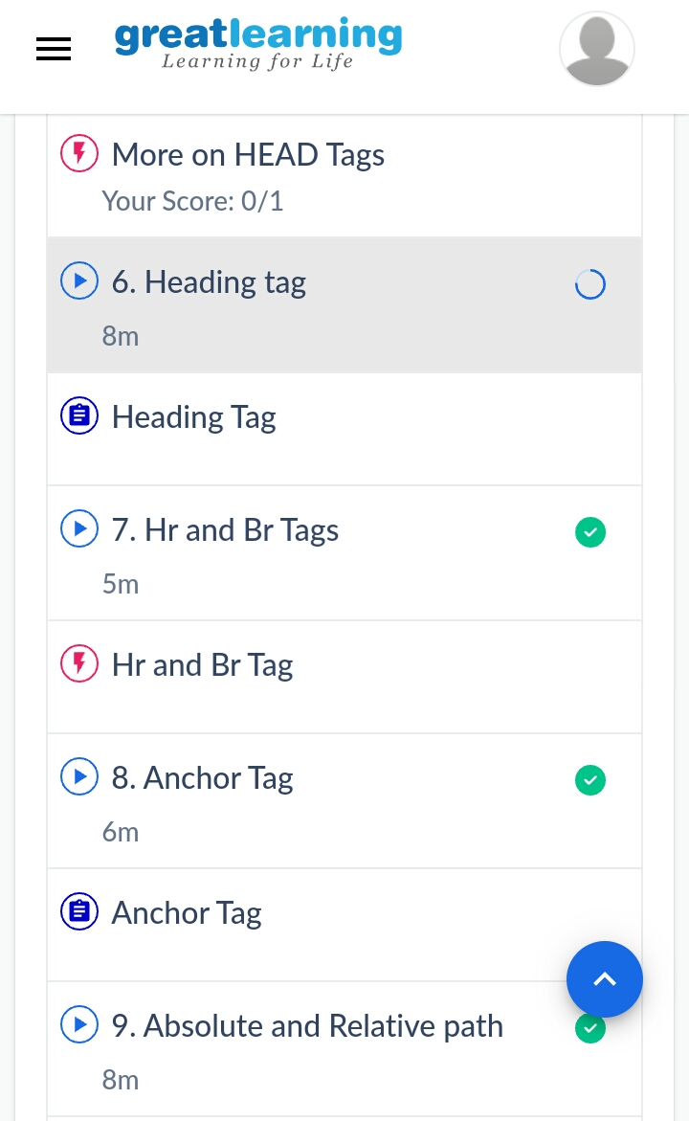

3) coding challenges

Program 1

*#include*<stdio.h>

int main()

{

int n,i;

long a[1000];

int mul=1;

scanf("%d",&n);

for(i=0;i<n;i++)

{

scanf("%ld",&a[i]);

}

for(i=0;i<n;i++)

{

mul=(mul*a[i])%(1000000007);

*// printf("%d",mul);*

}

printf("%d",mul);

}

**Program 2**

*#include* <stdio.h>

  int main(){

int num;

int fact=1;

scanf("%d", &num);

for(int i=1;i<=num;i++)

{

fact=fact*i;

}

printf("%d",fact);

}

|  |
| --- |
|  |
|  |  |
|  |  |
|  |  |
|  |  |
|  |  |